What is solubility?

Label which on is the solvent and which one is the solute
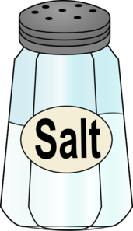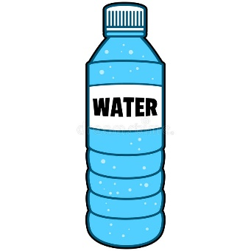

_______________ _________________

What is solubility?

Label which on is the solvent and which one is the solute

_______________ _________________

What is solubility?

Label which on is the solvent and which one is the solute

_______________ _________________

What is solubility?

Label which on is the solvent and which one is the solute

_______________ _________________

